**Installation Guide:**

1. Create a folder titled “lib” in the Java project. Add the .jar files from Blackboard into the folder.
2. Right click on the project name in the left sidebar in Eclipse. Go to Build Path > Configure Build Path.
3. Select Add External JARs on the right. When the new window appears select the JAR files in the lib folder. Click OK.
4. Run the program. It will create and populate any tables necessary.

**Instructions:**

See All Available Books: Click Display Books.

See All Patrons: Click List Patrons.

Check Out a Book: Fill in an ISBN from the list and a patron name. Click Check Out.

Return a Book: Fill in the ISBN and Patron name of the book you would like to return. Click Return.

Find a Borrower: Fill in the ISBN of the book you want to find and click Find Borrower.

See All Checked Out Books: Click Checked Out Books and every check out book will display.

**UML**

**Screenshots**

Display patrons: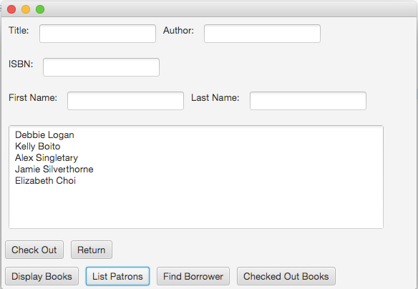

Display all books:

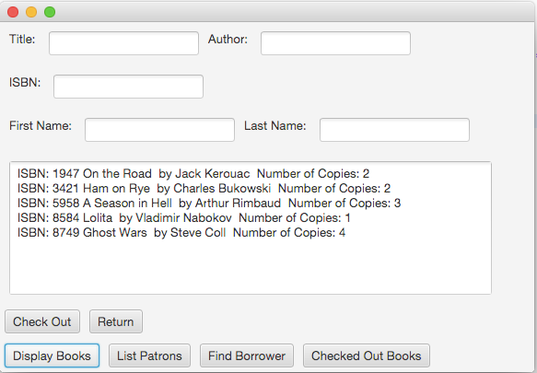

Check out book: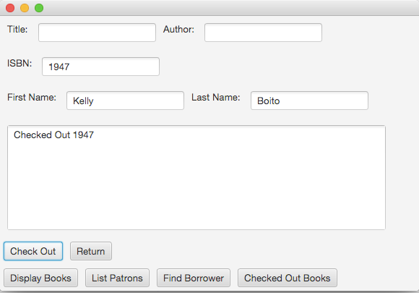

Return book: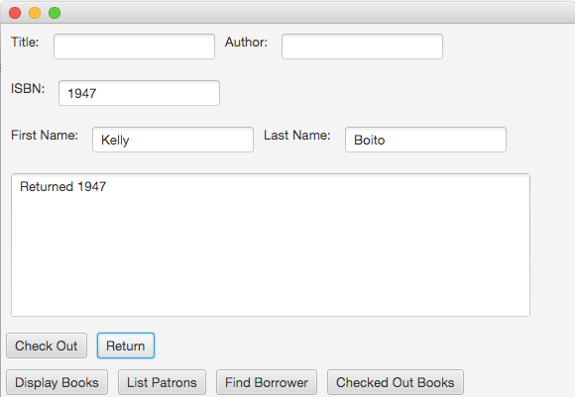

Find who borrowed a book:

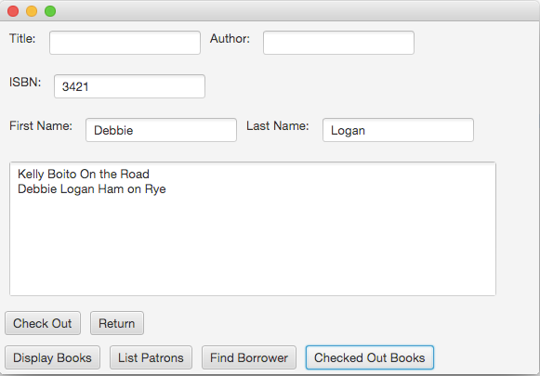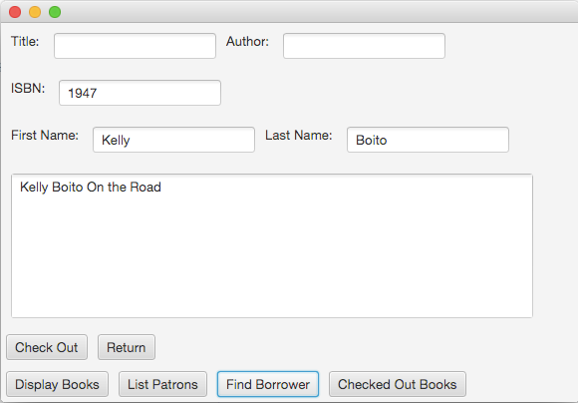

Display all checked out books: